<!DOCTYPE html>
<html lang="en">
<head>
<meta charset="UTF-8">
<title> 4- types of selectior</title>
<style>
#folder {
/*ID selector */
color: #001563;
background-color: palegreen;
border: solid;
border-color: #442200;
border-width: 5px;
border-radius: 10px;
border-height:5px;
height: 150px;
width: 900px;
border-radius: 23px;
padding: 45px 180px 100px 125px;
margin-bottom: 50px;
}
.clsfolder{
/*CLASS selector */
font-style:bold;
color:purple;
background-color:orchid;
border: solid;
border-color: #001563;
border-radius: 10px;
border-width: 5px;
border-height:2px;
height: 150px;
width: 900px;
padding: 45px 180px 100px 125px;
border-radius: 23px;
}
body
{
/*grouping selector */
/*INTERNAL CSS*/
background-image: url("flower.jpg");
background-repeat: no-repeat;
}
*
{
font-style: italic;
font-style:bold;
}
</style>
</head>
<body>
<!-- INLINE CSS -->
<h1 style="color: darkviolet" align="center" > Main heading</h1>
<div id="folder">
<h2> FIRST PARAGRAPH</h2>
<p>
A simple paragraph is comprised of three major components. The first sentence, which is often a declarative sentence,<br>
is called the “topic sentence.”It introduces the topic of the paragraph, setting its tone and mood. The next few sentences<br>
elaborate, explain,and exemplify the topic introduced in it A simple paragraph is comprised of three major components. <br>
The first sentence, which is often a declarative sentence, is called the “topic sentence.”It introduces the topic of the paragraph, <br>
setting its tone and mood. The next few sentences elaborate, explain,and exemplify the topic introduced in it<br>
</p>
</div>
<div class="clsfolder">
<h2> SECOND PARAGRAPH</h2>
<p>
A simple paragraph is comprised of three major components. The first sentence, which is often a declarative sentence,<br>
is called the “topic sentence.”It introduces the topic of the paragraph, setting its tone and mood. The next few sentences<br>
elaborate, explain,and exemplify the topic introduced in it A simple paragraph is comprised of three major components. <br>
The first sentence, which is often a declarative sentence, is called the “topic sentence.”It introduces the topic of the paragraph, <br>
setting its tone and mood. The next few sentences elaborate, explain,and exemplify the topic introduced in it<br>
</p>
</div>
</body>
</html>
OUTPUT
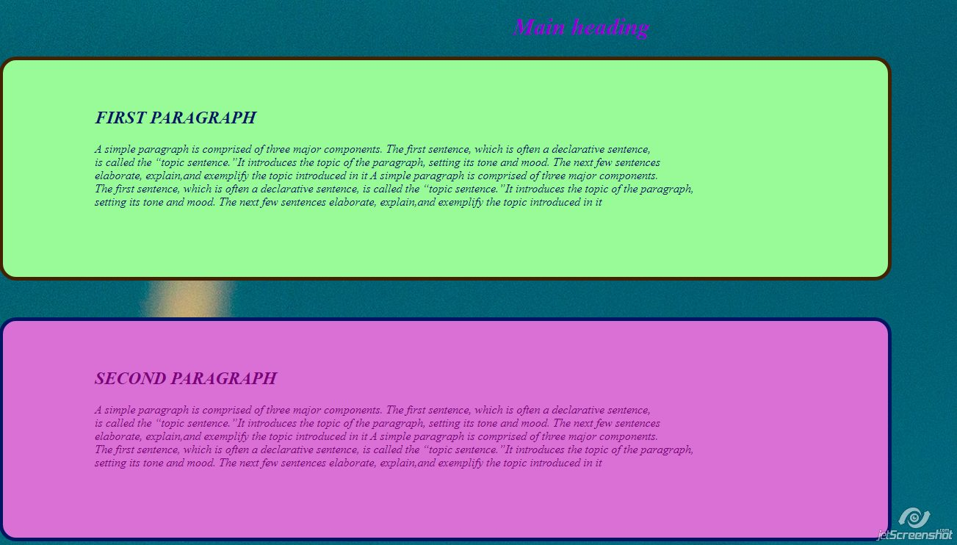

Using External
HTML FILE

<!DOCTYPE html>
<html lang="en">
<head>
<meta charset="UTF-8">
<title>HW 2</title>
<link rel="stylesheet" type="text/css" href="nine.css">
</head>
<body>
<h1>this paragraph using external css</h1>
<p>
A simple paragraph is comprised of three major components. The first sentence, which is often a declarative sentence,<br>
is called the “topic sentence.”It introduces the topic of the paragraph, setting its tone and mood. The next few sentences<br>
elaborate, explain,and exemplify the topic introduced in it
A simple paragraph is comprised of three major components. The first sentence, which is often a declarative sentence,<br>
is called the “topic sentence.”It introduces the topic of the paragraph, setting its tone and mood. The next few sentences<br>
elaborate, explain,and exemplify the topic introduced in it
</p>
</body>
</html>
CSS FILE
h1
{
text-align: center;
}
p
{font-style:bold;
color:white;
background-color:blue;
border: solid;
border-color: #001563;
border-radius: 10px;
border-width: 5px;
border-height:2px;
height: 80px;
width: 900px;
padding: 45px 180px 100px 125px;
}
OUTPUT
